Creating Git Repo:

1. Create a user in Github.
2. Open Profile and check the chart board and all option you will find in Git Dash board

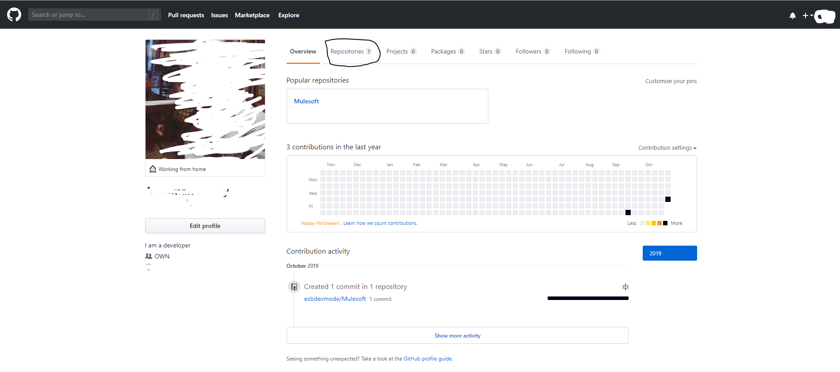

1. Go option Repositories and check your exist or create a new one.

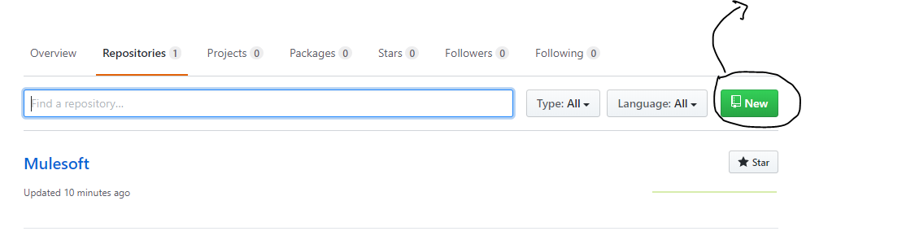

1. Once repo created updated your file or your project related content in the repo. 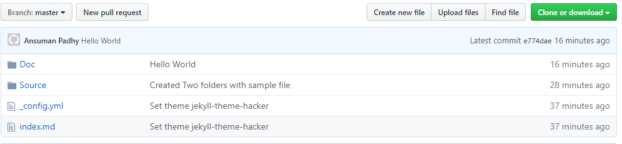
2. Making a local cloning for easy access and getting all updates in single pull or update your local changes in a single push in Git repo.

Steps of cloning.

1. Copy the cloning link.

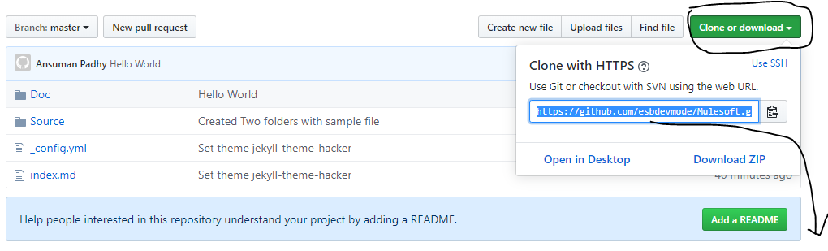

1. Download SourceTree for accessing the cloning link.
2. Choose your branch and clone in to a local directory.
3. Once cloning process completed, all cloned files will be visible in your local directory.
4. Note: Clone every branch in a separate folder. Easy to access and making changes will be identical as per the requirement.
5. Operations we do in repository:
   1. **Fetch**: Any new update in Git repo will get reflect in local before for a check for pull request
   2. **Pull**: Changes you want to push it from Git repo to your local.
   3. **Push**: Changes you want to push it from Local to Git repo.
   4. **Commit**: For committing the changes in both the side.
   5. **Merge**: Merging is a process to merge branches to make sure one branch will have the right code of your last committed work.

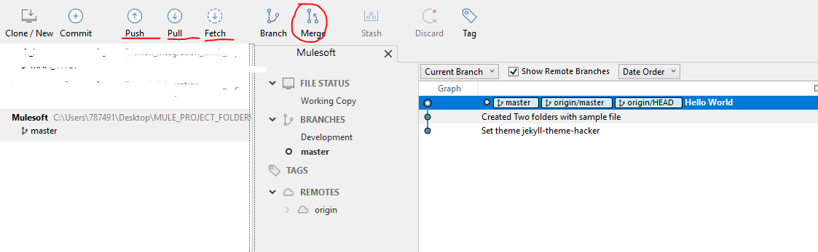

1. Branch:
   1. Master: Default branch of your project
   2. Sub Branch: Branch you are working for a temporary purpose. Sub branches are having different use cases as per the requirement.
2. A scenario where we do changes in dev branch and we want a pull request for merging the same code in to master

Compare and pull request.

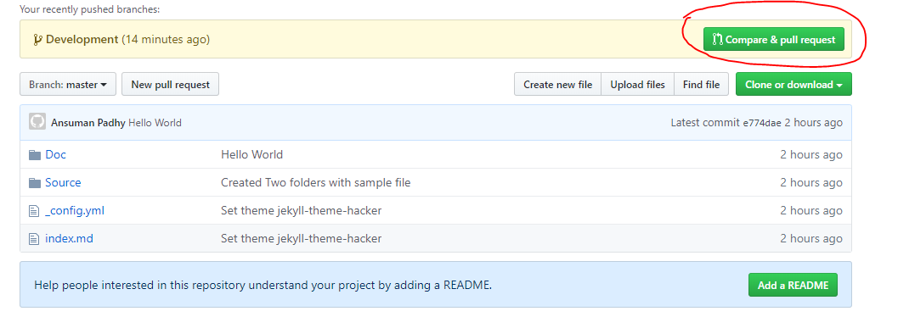

Check the merge options.

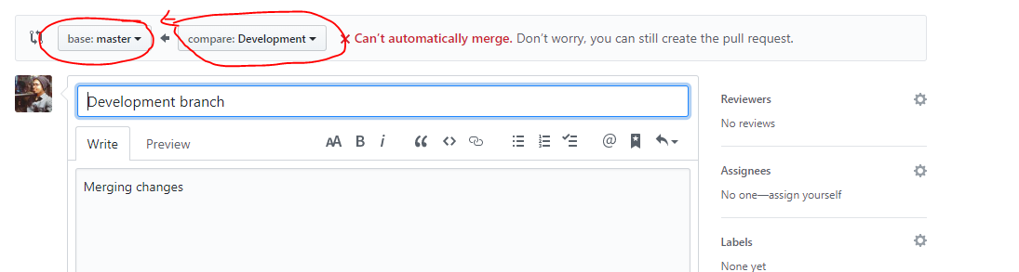

If you have code in master branch and its look like a change then it will pop up as conflict and we need to resolve it ASAP before merging it.

